I computed the direction of activity change of each node by subtracting the value predicted by SFA for MDAMB231 from that predicted for MCF10A. Then I plotted the nodes in a histogram as can be seen below. The different coloring on each graph identifies those nodes that could be considered readout nodes opposed to those that would not, depending on the method used to identify potential readout nodes. Red indicates a node that isn’t a potential readout node (RON), whereas blue denotes a node that is a potential readout node.

The first separation I tried is what we have been using to identify potential RONs: Those nodes with a positive value in one cell line but a negative value in the other. That produced this graph. As you can see, there are several nodes that have a larger direction of activity change, but since they do not have opposite signs in the two cell lines, they are not considered RONs. With this method, we have 35 candidate readout nodes.

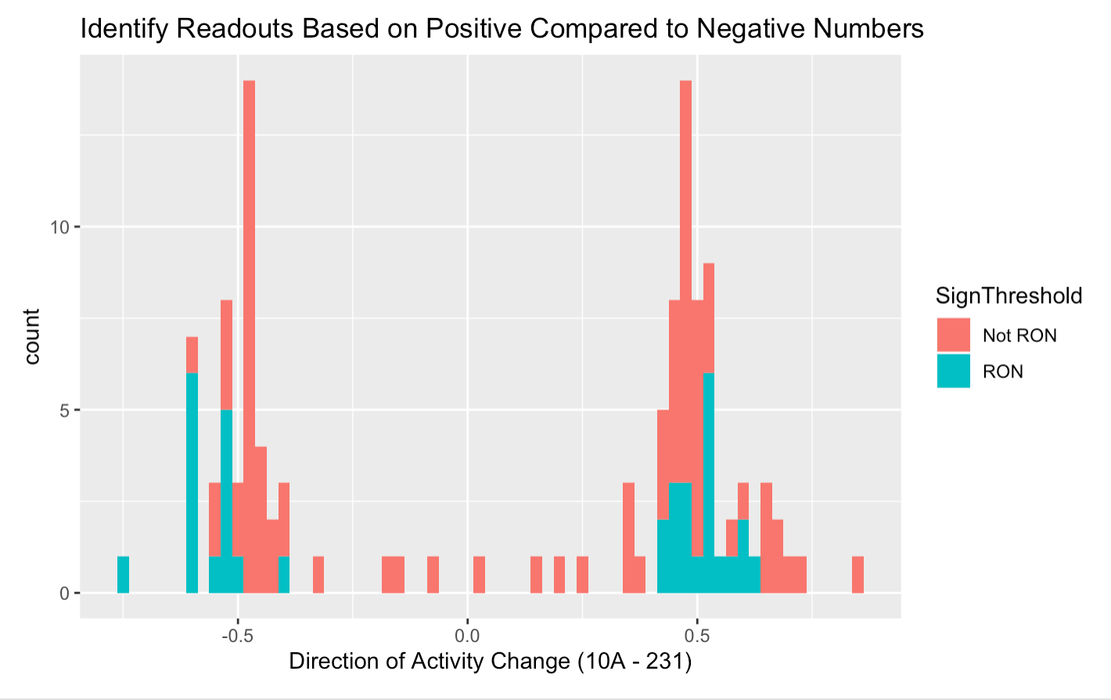

Next, I tried two different thresholds for direction of activity change. First, if the magnitude of the activity change was greater than or equal to 0.4, it would be considered a RON. This resulted in 103 candidate RONs. The graph can be seen below.

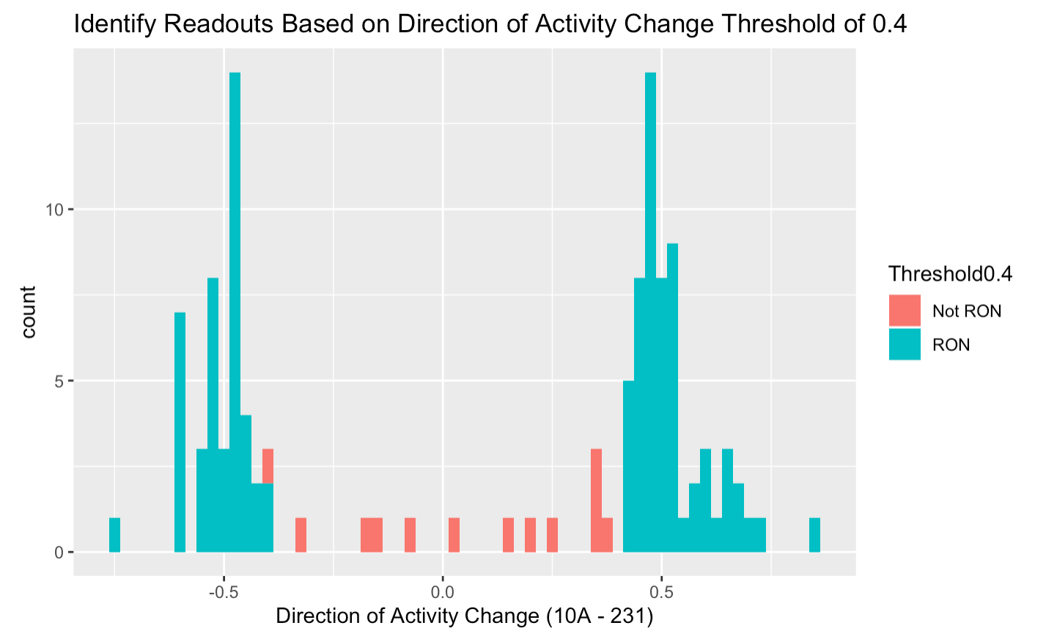

I tried the same thing but with a threshold of 0.5 instead, which produced 52 candidate readout nodes.

